FOR IMMEDIATE RELEASE

CBRE ISSUES U.S. LODGING AND 2019-2020 HISTORIC HOTELS FORECAST AT HISTORIC HOTELS OF AMERICA ANNUAL CONFERENCE

Historic Hotels achieve a substantial premium in ADR and RevPAR over comparable contemporary hotels. RevPAR forecast to grow faster for Historic Hotels than upper upscale Hotels.

WASHINGTON, DC – January 10, 2019 The outlook for the U.S. lodging industry, particularly historic hotels, continues to be extremely strong, according to CBRE Hotels’ Americas Research (CBRE).

For the fourth consecutive year, CBRE Hotels’ Americas Research presented a Historic Hotels of America – CBRE five-year forecast at the Historic Hotels of America annual conference. CBRE relies on historical hotel performance data from STR, and economic forecasts from CBRE Economic Advisors, to prepare its lodging forecasts.

Key points presented by Mark Woodworth, Senior Managing Director at CBRE, to more than 240 owners, asset managers, general managers, and sales and marketing leaders at the Historic Hotels of America annual conference at The Broadmoor (1918) include:

- Per STR, through the first three quarters of 2018, the aggregate RevPAR for historic hotels that are members of Historic Hotels of America placed between the national averages for all upper upscale and all luxury hotels in the U.S. (Luxury RevPAR $250.76, upper upscale RevPAR $140.48).

- Over the next two years (2019 and 2020), RevPAR for historic hotels is expected to grow at an average annual rate of 1.45 percent, which is more than the RevPAR forecast for the nation’s upper upscale hotels at 0.5 percent, but less than luxury hotels at 3.95 percent. Most of the RevPAR growth is expected to stem from increases in ADR.

- Annual occupancy levels for hotels that are members of Historic Hotels of America remains approximately 8.3 percent points above the national average occupancy level through 2020.

- Based on a set of information pulled from CBRE’s database of hotel operating statements, historic hotels (including those that are not members of Historic Hotels of America) had an average ADR of $277.87, higher by more than 16.36 percent than the $238.78 ADR for contemporary hotels. (See chart below)

- Since 2009, historic resort hotels have achieved greater revenue and profit growth compared to their contemporary counterparts.
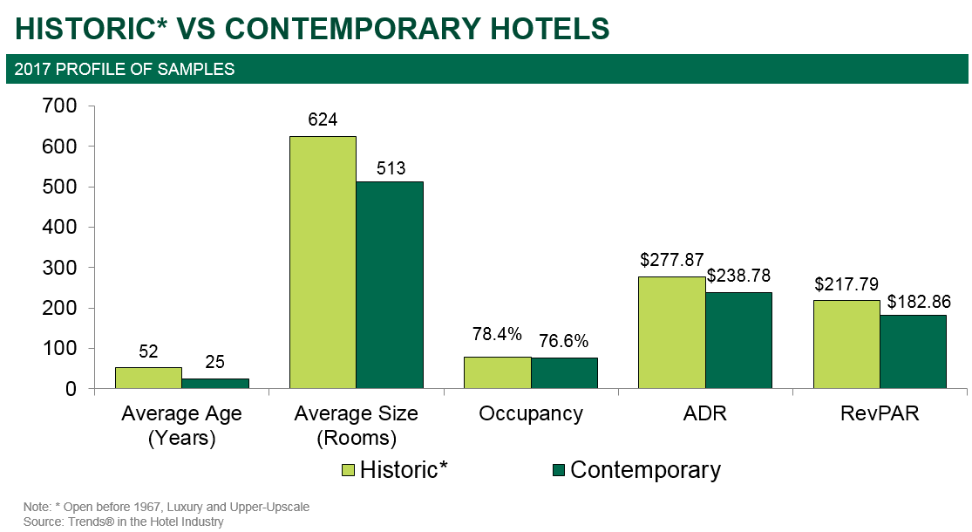

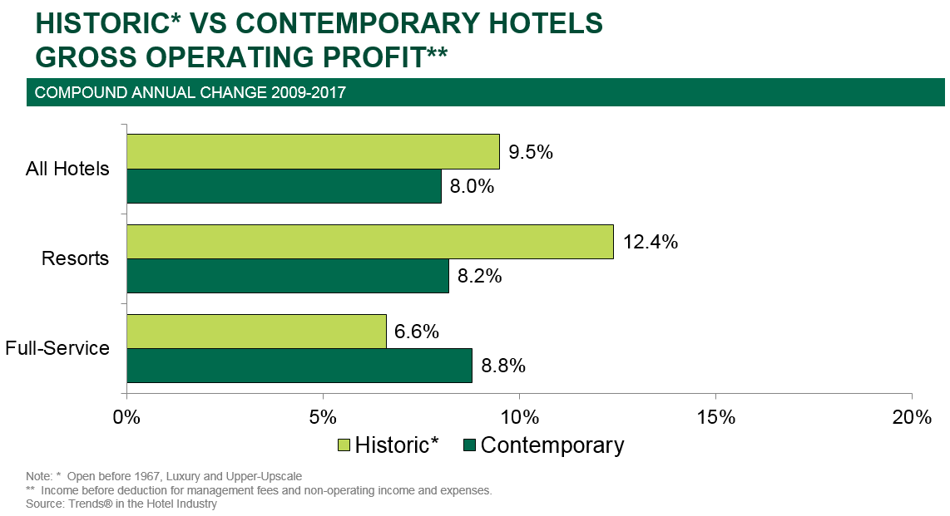

“The data strongly supports the idea that many consumers favor and will pay more for the unique hotel experience historic properties can offer,” noted Woodworth.

“Historic Hotels of America helps the consumer differentiate the authentic historic hotel from other older hotels,” said Lawrence Horwitz, Executive Director, Historic Hotels of America and Historic Hotels Worldwide. “Historic hotels can achieve a significant advantage in ADR and REVPAR versus contemporary hotels, especially when recognized as part of Historic Hotels of America. While promoting its history helps a historic hotel differentiate itself from other hotels, being part of Historic Hotels of America validates the differentiation. For the fifth year in a row, historic hotels inducted into and participating in Historic Hotels of America realize a competitive advantage as well as a substantial premium with their rates, occupancy and RevPAR compared to other hotels.”

CBRE Hotels is a specialized advisory group within CBRE providing capital markets, consulting, investment sales, and research and valuation services to companies in the hotel sector. CBRE Hotels is comprised of more than 385 dedicated hospitality professionals located in 60 offices across the globe.
About Historic Hotels of America®
Historic Hotels of America is the official program of the National Trust for Historic Preservation for recognizing and celebrating the finest Historic Hotels. Historic Hotels of America includes more than 300 historic hotels, historic resorts, and small historic inns. These historic hotels have all faithfully maintained their authenticity, sense of place, and architectural integrity in the United States of America, including 44 states, the District of Columbia, the U.S. Virgin Islands, and Puerto Rico. Historic Hotels of America is comprised of mostly independently owned and operated properties. More than 30 of the world’s finest hospitality brands, chains, and collections are represented in Historic Hotels of America. To be nominated and selected for membership into this prestigious program, a hotel must be at least 50 years old; has been designated by the U.S. Secretary of the Interior as a National Historic Landmark or listed in or eligible for listing in the National Register of Historic Places; and recognized as having historic significance. For more information, please visit HistoricHotels.org.

MEDIA CONTACT: Heather Taylor
Historic Hotels of America
Senior Manager, Marketing Communications
Tel: +1 202 772 8333 Fax: +1 202 772 8338
htaylor@historichotels.org

CBRE CONTACT: R. Mark Woodworth
CBRE
Senior Managing Director
Tel : +404 812 5085
mark.woodworth@cbre.com

